Personal Assistance for Seniors Who Are Self-Reliant

NALAIYA THIRAN PROJECT BASED LEARNING

on

PROFESSIONAL READINESS FOR INNOVATION, EMPLOYABILITY AND ENTREPRENEURSHIP

**A PROJECT REPORT**

|  |  |
| --- | --- |
| SIVASURIYAM | 19104149 |
| RISHIKESH GOVIND | 19104149 |
| VISHWA | 19104176 |
| SUJEETH | 19104601 |

BACHELOR OF TECHNOLOGY

IN INFORMATION TECHNOLOGY

**HINDUSTHAN COLLEGE OF ENGINEERING AND TECHOLOGY**

Approved by AICTE, New Delhi, Accredited with ‘A’ Grade by NAAC

**(An Autonomous Institution, Affiliated to Anna University, Chennai)**

**COIMBATORE – 641 032**

November 2022

**TABLE OF CONTENTS**

|  |  |  |
| --- | --- | --- |
| **CHAPTER NO** | **TITLE** | **PAGE NO** |
|  | **ABSTRACT** | **i** |
| **1** | **INTRODUCTION** | **1** |
| **2** | **OBJECTIVE** | **3** |
| **3** | **IDEATION PHASE** | **5** |
|  | **3.1 Literature Survey** |  |
|  | **3.2 Empathy Map** |  |
|  | **3.3 Ideation** |  |
|  | **3.4 Problem Statement** |  |
| **4** | **PROJECT DESIGN PHASE 1** |  |
|  | **4.1 Proposed Solution** |  |
|  | **4.2 Problem Solution Fit** |  |
|  | **4.3 Solution Architecture** |  |
| **5** | **PROJECT DESIGN PHASE 2** |  |
|  | **5.1 Customer Journey Map** |  |
|  | **5.2 Solution Requirements** |  |
|  | **5.3 Data Flow Diagrams** |  |
|  | **5.4 Technology Stack** |  |
| **6** | **PROJECT PLANNING PHASE** |  |
| **6.1 Prepare Milestone and Activity List** | |
|  | **6.2 Sprint Delivery Plan** |  |
| **7** | **PROJECT DEVELOPMENT PHASE** |  |
| **7.1 Project Development - Delivery of Sprint - 1** | | |
| **7.2 Project Development - Delivery of Sprint - 2** | | |
| **7.3 Project Development - Delivery of Sprint - 3** | | |
| **7.4 Project Development - Delivery of Sprint - 4** | | |
| **8** | **CONCLUSION** | **33** |
| **9** | **REFERENCES** | **49** |

#### Abstract

There is a significant increase in the geriatric population across the globe. With the increase in the number of geriatric people and their associated health issues, the need for larger healthcare resources is inevitable. Because of this, healthcare service-providing industries are facing a severe challenge. However, technological advancement in recent years has enabled researchers to develop intelligent devices to deal with the scarcity of healthcare resources. In this regard, the Internet of things (IoT) technology has been a boon for healthcare services industries. It not only allows the monitoring of the health parameters of geriatric patients from a remote location but also lets them live an independent life in a cost-efficient way. The current paper provides up-to-date comprehensive knowledge of IoT-based technologies for geriatric healthcare applications. The study also discusses the current trends, issues, challenges, and future scope of research in the area of geriatric healthcare using IoT technology. Information provided in this paper will be helpful to develop futuristic solutions and provide efficient cost-effective healthcare services to the needy.

#### 1. Introduction

The rapid advancements in clinical science and technologies have significantly increased the average life expectancy of humans across the globe [1]. This led to a substantial rise in the geriatric population. In 2015, the number of geriatric people was nearly equal to 8.5% of the world population and it was estimated that it will increase to 12% and 16.7% by the years 2030 and 2050, respectively [2]. As compared to other age groups, elderly persons are more prone to several health-related issues such as diabetes, hypertension, asthma, and chronic diseases. Hence, the elderly group of people needs the utmost attention in terms of medication, treatment, and care especially if they chose to live an independent life. The prime constraint in availing of a good healthcare service is its rising cost [3]. Also, the aged group cannot be physically present at the health center each time they face a health issue. The reason may be either the increased cost or the unavailability of a good health center with all advanced technologies. This has inspired various research communities to go for other alternatives that can reduce the expenditure while delivering quality healthcare services to the patients. With the wide use of advanced technologies and Internet services, and sensors, it is now possible to avail a range of healthcare services at home. This allows the geriatric people to lead an independent life while receiving standard clinical service at home.

Project Objective

* To Gain knowledge of Watson IoT Platform.
* Connecting IoT devices to the Watson IoT platform and exchanging the sensor data.
* Gain knowledge on IBM Text to Speech Service
* Explore python client libraries of Watson IoT Platform ,Text toSpeech Service.
* Gain knowledge on IBM Cloudant DB
* Creating a Web Application that interacts with IoT device
* Create and configure IBM Cloud Services
  + Create IBM Watson IoT Platform
  + Create a device & configure the IBM IoT Platform
  + Create Node-RED service
  + Create text to speech service
  + Create a database in Cloudant DB to store medicinedetails
* Develop a web Application using Node-RED Service
* Develop a python script to subscribe to the IBM IoTplatform & Generate voice alerts

IDEATION PHASE

1.Literature survey

# REVIEW-1:

## Title of the Paper:

Elderly Care: A Study on Community Care Services in Sleman, DIY, Indonesia

## Name of the Author:

Academic Editor: Jean-Francois Grosset Published on 07 May 2020

## Problem Description:

Elderly care services are important to provide in response to the rapid growth of the elderly population. In developing countries like Indonesia, the speed of growth of the elderly population does not simultaneously occur, so the needs for care services vary. This study discusses the emergence of home care services in response to the increase in elderly population. By taking the case of community home care services in Sleman, this study found the pattern and process of the emergence of local initiatives in home care services. This study also revealed an important factor affecting the implementation of community home care services, that is, leadership.

# REVIEW-2:

## Title of the Paper:

Multidisciplinary approaches to achieving efficient and trustworthy eHealth monitoring systems

## Name of the Author:

Ajmal Sawand, Soufiene Djahel, Zonghua Zhang, Farid NaïtAbdesselam

Published on 2014 IEEE/CIC International Conference on Communications in China (ICCC), 187-192, 2014

## Problem Description:

The rapid technological convergence between Internet of Things (IoT), Wireless Body Area Networks (WBANs) and cloud computing have contributed to the emergence of e-healthcare, significantly improving the quality of medical care. In particular, patient-centric health monitoring plays a vital role in e-healthcare service, involving a set of important operations ranging from medical data collection and aggregation, data transmission and segregation, to data analytics. This survey paper firstly presents an architectural framework to describe the entire monitoring life cycle and highlight the essential service components. More detailed discussions are then devoted to data collection at patient side, which we argue that it serves as fundamental basis in achieving robust, efficient, and secure health monitoring. Finally, a set of design challenges is particularly analyzed for developing high quality and secure patient- centric monitoring schemes, along with some potential solutions.

# REVIEW-3:

## Title of the Paper:

Developing the Medication Reminder Mobile Application “Seeb”

## Name of the Author:

Sakineh Saghaeiannejad-Isfahani, Asghar Ehteshami and Ali Samimi

## Problem Description:

Today, the structure of comprehensive health care emphasizes self- care more than therapy. Medication therapy is a strong instrument for therapy received through the health setting, especially in medication area. Error in medication administration has produced different problems and they cost billions of dollars every year. Regarding mobile phone extensions, we developed a local medication reminder mobile application called “Seeb” as a suitable solution for decreasing medication errors for Iranians. This application was designed for the appropriate medication administration including time and dosages through: recording patient and medication data; scheduling patients’ medication; and reporting medication administration on progress. Nowadays, using smart phones and mobile applications are increased dramatically, so developing mobile applications in health services (especially self- care) can create the desired effect in the community. Although there are various medication reminder mobile applications, a native mobile application is essential that is developed on the basis of the specialists’ ideas in this field. In addition to remind the medication administration time and dose, “Seeb” reports the analysis of the patient medication administration, as well as displaying suitable picture of the medication and its administration method when reminded of medication use. Existence of these functions in the medication reminder mobile application prevents medication errors by patients and increases medication adherence. Undoubtedly, “Seeb” can play an important role in patient health improvement with the suitable reminder of the medication administration by user friendly interfaces, data processing, correct calculation of formulas and appropriate responds, the display of the medication pictures and descriptions. Therefore, we suggest that health care providers increase patients’ awareness and introduce them medication reminder mobile applications to promote these applications utilization and to improve medication adherence as well as decreasing medication errors.

# REVIEW-4:

## Title of the Paper:

Salubrity-A medicine reminder application using android

## Name of the Author:

Shivani Sharma

Published 2018 Medicine, Computer Science

## Problem Description:

Nowadays, smartphones have reached every hand and every home. As a result, people are making use of the beneficial mobile applications to make their everyday life easier. This paper focuses on the development of a mobile application to help to provide an effective health care system. This is an android based application in which alarm is used which may be closed by tapping the close alarm button, under the image of the medicine which is to be taken at that particular time. It may even have the contact numbers of the doctors for an emergency. This application will be helping hand for the people who are busy in their day to day life or old age people who forget which medicine is to be taken and when. Many such medicine reminder systems have been developed where a new hardware is required but in our work, we have made an attempt to develop a system which is free of cost, time-saving and supports medication adherence without any extra hardware.

# References:

1.A. Sawand, S. Djahel, Z. Zhang, and F. Na. Multidisciplinary Approaches to Achieving Efficient and Trustworthy e Health Monitoring Systems. Commun .China (ICCC), 2014 IEEE/CIC Int. Conf., pp. 187–192, 2014.

1. D. a. Clifton, D. Wong, L. Clifton, S. Wilson, R. Way, R. Pullinger, and L. Tarassenko. A large-scale clinical validation of an integrated monitoring system in the Emergency Department. IEEE J. Biomed. Heal. Informatics vol. 17, no. 4, pp. 835–842, 2013.
2. M. Parida, H.-C.Yang, S.-W.Jheng, and C.-J. Kuo.Application of RFID Technology for In-House Drug Management System.15th Int. Conf.Network-Based Inf. Syst., pp. 577–581, 2012.
3. L. Ilkko and J. Karppinen.UbiPILL A Medicine Dose Controller of Ubiquitous Home Environment. 2009 Third Int. Conf. Mob. UbiquitousComput.Syst. Serv. Technol., pp. 329–333, 2009.
4. A. Kliem, M. Hovestadt, and O. Kao.Security and Communication Architecture for Networked Medical Devices in Mobility-Aware e Health Environments,” 2012 IEEE First Int. Conf. Mob. Serv., pp. 112–114, 2012.
5. S. T.-B. Hamida, E. Ben Hamida, B. Ahmed, and A. AbuDayya.Towards efficient and secure in-home wearable insomnia monitoring and diagnosis system.13th IEEE Int. Conf. Bioinforma. Bioeng., pp. 1–6, 2013.
6. P. Ray.Home Health Hub Internet of Things (H 3 IoT): An architectural framework for monitoring health of elderly people.Sci. Eng. Manag.Res, pp. 3–5, 2014.
7. S. Huang, H. Chang, Y. Jhu, and G. Chen.The Intelligent Pill Box

- Design and Implementation.pp. 235–236, 2014.

1. F.-T. Lin, Y.-C.Kuo, J.-C.Hsieh, H.-Y.Tsai, Y.-T. Liao, and H. C. Lee A Self-powering Wireless Environment Monitoring System Using Soil Energy. IEEE Sens. J., vol. 15, no. c, pp. 1–1, 2015.
2. S. S. Al-majeed.HomeTelehealth by Internet of Things (IoT).pp. 609–613, 2015.

**Empathy Map Canvas:**

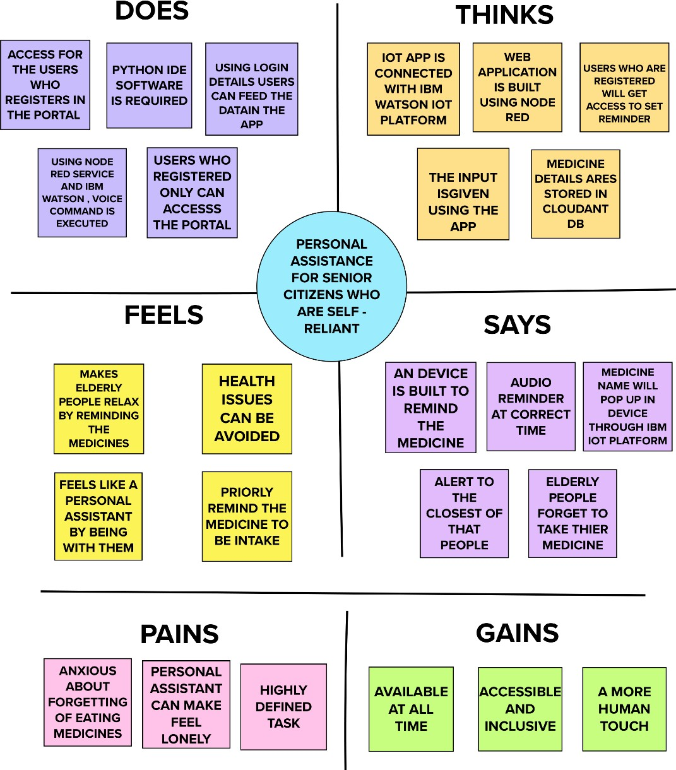

Reference:[https://app.mural.co/invitation/mural/balamurugansam45gmailcom1469/16659](https://app.mural.co/invitation/mural/balamurugansam45gmailcom1469/1665924809930?sender=u7ee4ef2bc8279c756ef56351&key=3436ad58-a40e-499a-9302-b560aa568c7f) [24809930?sender=u7ee4ef2bc8279c756ef56351&key=3436ad58-a40e-499a-9302-](https://app.mural.co/invitation/mural/balamurugansam45gmailcom1469/1665924809930?sender=u7ee4ef2bc8279c756ef56351&key=3436ad58-a40e-499a-9302-b560aa568c7f) [b560aa568c7f](https://app.mural.co/invitation/mural/balamurugansam45gmailcom1469/1665924809930?sender=u7ee4ef2bc8279c756ef56351&key=3436ad58-a40e-499a-9302-b560aa568c7f)

**Brainstorm & Idea Prioritization:**

Reference:[https://app.mural.co/invitation/mural/sridharanr2543/1666004422862?sender=uf5509](https://app.mural.co/invitation/mural/sridharanr2543/1666004422862?sender=uf5509b498aa0440833a02996&key=c4d55e0c-ed8d-4c47-93d0-a134a4e64609) [b498aa0440833a02996&key=c4d55e0c-ed8d-4c47-93d0-a134a4e64609](https://app.mural.co/invitation/mural/sridharanr2543/1666004422862?sender=uf5509b498aa0440833a02996&key=c4d55e0c-ed8d-4c47-93d0-a134a4e64609)

**Step-1: Brainstorm, Idea Listing and Grouping**

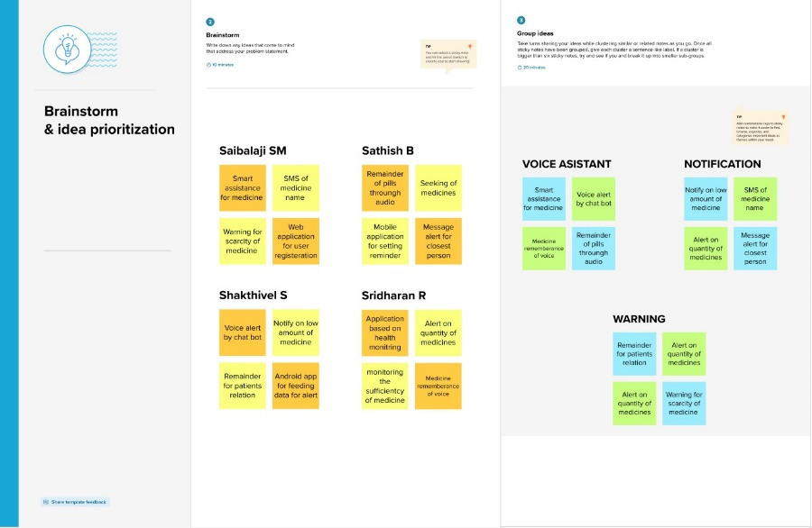

**Step-2: Idea Prioritization**

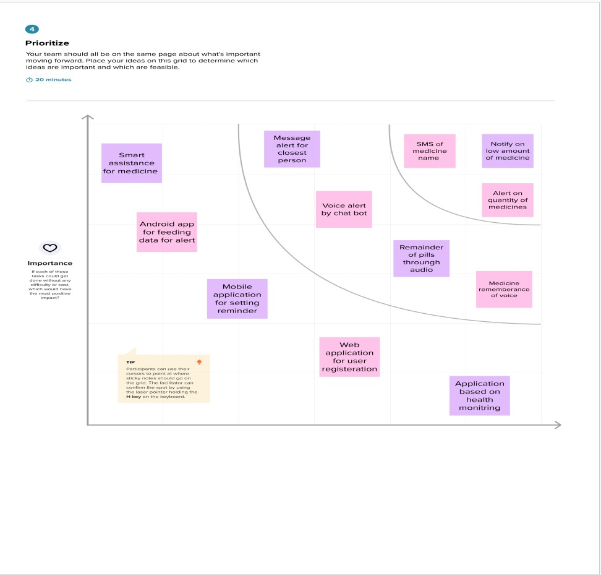

**Customer Problem Statement:**

It is very difficult for the senior citizens (elder people) to remember their medicines. To avoid the skipping up the medicines,they can be remembered by using the voice commands of the medicine names at correct time specified. If the voice commands on the medicine name is not available, they are given the reminder of the medicine by SMS on their phone or to their closest person.

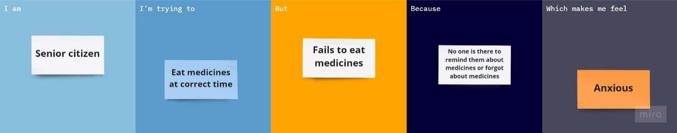

Reference: [https://miro.com/app/board/uXjVPNRNvzg=/?share_link_id=213829070965](https://miro.com/app/board/uXjVPNRNvzg%3D/?share_link_id=213829070965)

|  |  |  |  |  |  |
| --- | --- | --- | --- | --- | --- |
|  | **I am (Customer)** | **I’m trying to** | **But** | **Because** | **Which makes me feel** |
| PS-1 | Senior citizen who is self- reliant. | Eat medicines at correct time | Fails to eat | No one is there to remind about medicines or forgot by  themselves | anxious |

Project design phase

**Proposed Solution:**

|  |  |  |
| --- | --- | --- |
| **S.No** | **Parameter** | **Description** |
| 1 | Problem Statement (Problem to be solved) | Senior citizens who are in need of medicine reminder and self-assistance because they  don't want to skip their intake of medicine |
| 2 | Idea / Solution description | Creation of the web application which remind the medicine name and time through a voice  alert |
| 3 | Novelty / Uniqueness | Blind people can get to know their time of  taking pills |
| 4 | Social Impact / Customer Satisfaction | The users are satisfied with the proper  reminder and intake of pills |
| 5 | Business Model (Revenue Model) | By our web application the revenue can be made in the form of popping up of advertisements or by overlaying add from third  party services |
| 6 | Scalability of the Solution | Vast number of people who are aged can be provided with portable devices to ensure their health conditions by consuming medicines at  correct time using web application |

|  |  |  |  |  |
| --- | --- | --- | --- | --- |
| **Define CS, fit into CC** | 1. **CUSTOMER SEGMENT(S) CS**    * Here the customers are the elder people who needs to take medicine regularly at correct time.    * Patients who can’t be monitored 24X7 by doctors.    * Visually challenged people who   are self-reliant. | 1. **CUSTOMER CONSTRAINTS CC**    * Due to lack of internet.    * It should be present near to them.    * Knowing the process of using the applications.    * Registered user can use the application. | 1. **AVAILABLE SOLUTIONS AS**    * If customers forgot to take medicine ,medcare application helps them to take medicine at right time.    * Alert the customer by notification by SMS alarm.    * Make the registered users remind their medicines through voice commands of medicine names. | **Explore AS, differentiate** |
| **Focus on J&P, tap into BE, understand RC** | 1. **JOBS-TO-BE-DONE /PROBLEMS**   **J&P**   * + Rememberance of the medicine   to be consumed through voice.   * + Message sent on regarding intake of medicines to the closest persons.   + Alert the patient about the low   amount of medicine. | 1. **PROBLEM ROOT CAUSE RC**    * Doctors cannot monitor the   patients all the time.   * + Visually impaired persons needs an assistance.   + Elder people(self-reliant) who needs care to be taken. | **7. BEHAVIOUR BE**   * The customer can use ‘help’ option in the application to getthe problem solved. * The user can use user guide available in the ‘about’ section for reference. | **Focus on J&P, tap into BE, understand RC** |

|  |  |  |  |  |
| --- | --- | --- | --- | --- |
| **Identify strong TR & EM** | **3. TRIGGERS TR**   * The customers are introduced with this by the doctors. * By seeing ads on the internet. | **10. YOUR SOLUTION SL**  Notifying of medicines names through audio and message with the help of data fed from the mobile application which is initiated by web application which stores the user details. | **8.CHANNELS of BEHAVIOUR CH**  **ONLINE:**  Customers can set reminder about their medicines in online mode.  **OFFLINE:**  Customers get notification alert to take medicine on proper time in offline mode. | Extract onine & offline CHOF be |
| **4. EMOTIONS: BEFORE / AFTER EM**  **BEFORE**:  Customers forgot to take at right time which affect their health.  **AFTER:**  Now after using medcare applications customers are taking their medicines properly at correct time. |

**Solution Architecture:**

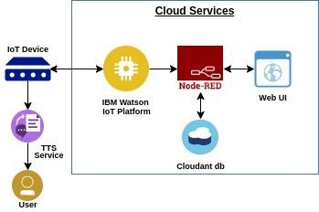

# IOT Device:

* Getting the information from the application about the time and name of the medicines.
* Sending an SMS to the persons.
* Gathering the user information from the web application in which the user registers.
* To accomplish this, we have to complete all the activities listed below:

PHASE 2

CUSTOMER JOUNRNEY MAP

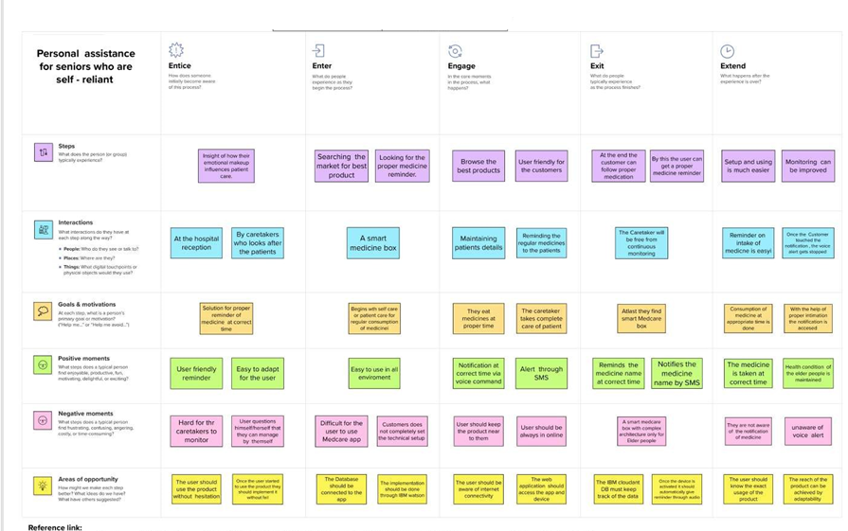

Solution Requirements

**Functional Requirements:**

|  |  |  |
| --- | --- | --- |
| **FR No.** | **Functional Requirement (Epic)** | **Sub Requirement (Story / Sub-Task)** |
| FR-1 | User Registration | Registration through Gmail  Registration by phone number |
| FR-2 | User Confirmation | Confirmation via Email  Confirmation through SMS/Messages |
| FR-3 | User Login (Web) | Login with registered mail id and password |
| FR-4 | User Login (mobile app) | Login with registered mobile number and password |
| FR-5 | User’s Medical Information | In the app, enter your medicine details with  date.Then set the time in the app. |

**Non-functional Requirements:**

|  |  |  |
| --- | --- | --- |
| **FR No.** | **Non-Functional Requirement** | **Description** |
| NFR-1 | **Usability** | The system should be user-friendly for the users. It is used to remaind the medicine names.  It alerts the users through voice commands. |
| NFR-2 | **Security** | The login information should not be accessed by anyother users than the respective.  The data of the users should be kept confidential. |
| NFR-3 | **Reliability** | Reminds on correct time  The user data should be updated and examined after certain period of time. |
| NFR-4 | **Performance** | The voice message will be delivered accurately to the given time.  It works without any connection interruption |
| NFR-5 | **Availability** | The system should be monitored 24X7 for the alert of medicines.  It can be used by any registered users from any place. |
| NFR-6 | **Scalability** | It is easily adaptable  The device is compatible and portable  The application can handle any number of registration. |

Data flow diagram

1. The user should register on MedCare(web application) by using their mail ID, password and get verified.
2. User can set medicine name and time by MedCare (mobile application).
3. The data given as input by the user on mobile application is stored in IBM Cloudant database.
4. The IOT device is made to remind the medicine name at correct time by voice commands through IBM Watson platform.
5. The SMS is sent to the user to notify the intake of medicine which is initiated by mobile application.

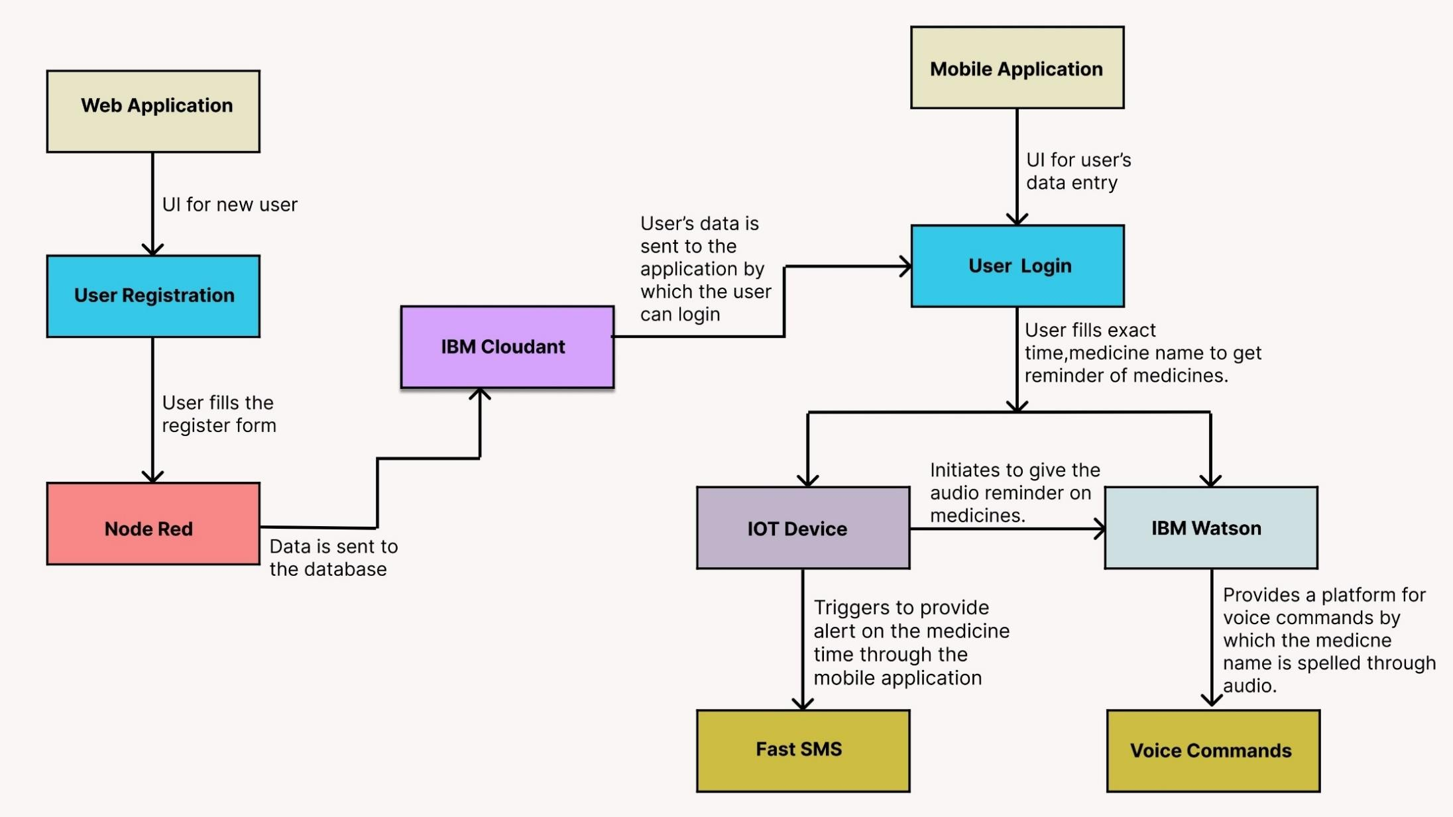

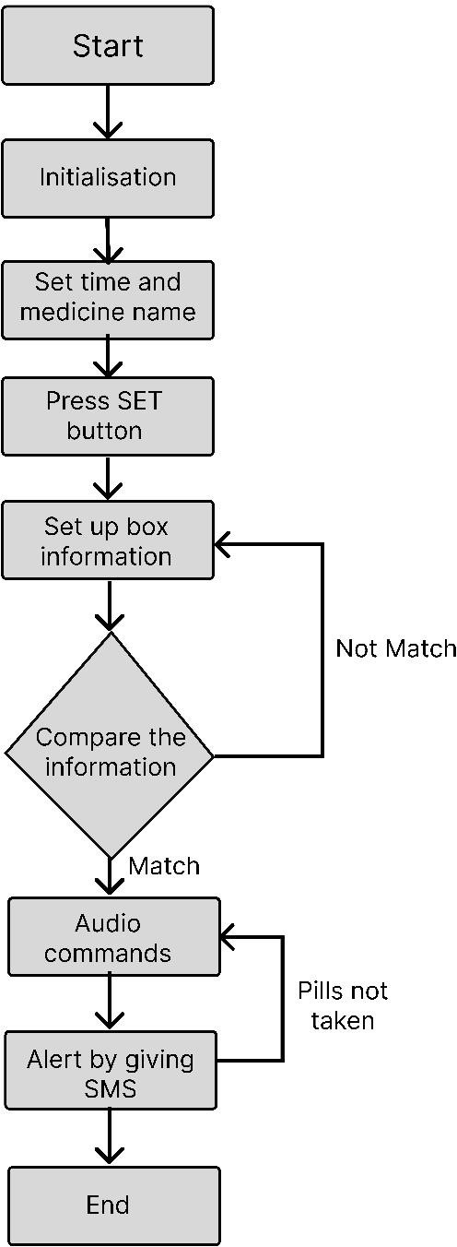

# User Stories:

|  |  |  |  |  |  |  |
| --- | --- | --- | --- | --- | --- | --- |
| **User Type** | **Functional Requirement (Epic)** | **User Story Number** | **User Story / Task** | **Acceptance criteria** | **Priority** | **Release** |
| Customer (Senior citizen) | Caretaker | USN-1 | As a user, I want to take medicines on time so that I can my health. | I want to take medicine on time. | High | Sprint-1 |
| Customer (Mentally idled patient) | Janitor | USN-2 | As a user, my patient should maintain good health by consuming medicines on time. | My patient needs to take medicines at proper time. | High | Sprint-2 |
| Customer (Disabled person) | Smart medicine box | USN-3 | As a user, I need to take my medicines at correct time through nearby person via SMS. | I need to take medicines at accurate time by notification. | Medium | Sprint-4 |
| Customer (Coma patient) | Virtual medikit | USN-4 | As a user, my patient medication time and name should be loaded in database. | My patient’s medicine name and time should be in database list. | High | Sprint-2 |
| Customer (Alzheimer patient) | Digital medicare | USN-5 | As a user, I want to take medicines on time by voice commands. | I want to take medicines on time by voice assist. . | Medium | Sprint-3 |

**Technical Architecture:**

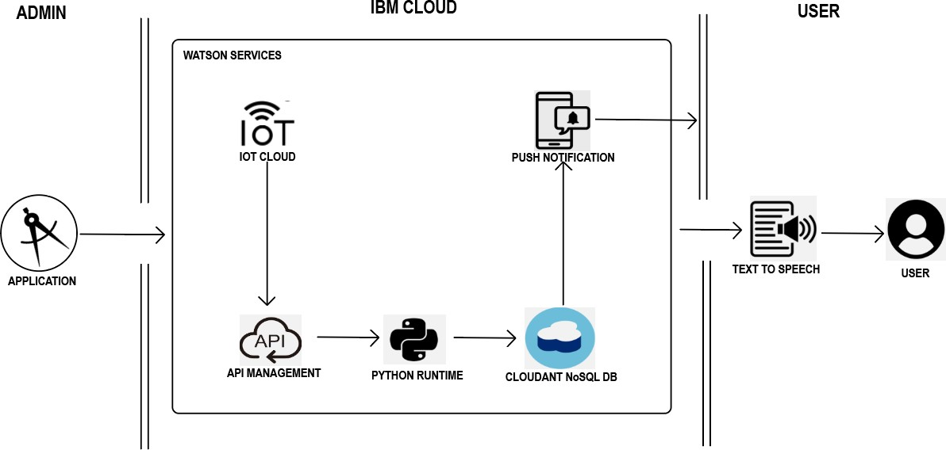

Table-1 : Components & Technologies:

|  |  |  |  |
| --- | --- | --- | --- |
| **S.No** | **Component** | **Description** | **Technology** |
| 1. | User Interface | Mobile App | HTML, CSS, JavaScript |
| 2. | Application Logic-1 | Mobile App to enter the Medicine details weekly | Python |
| 3. | Application Logic-2 | Gets the medication data from database | IBM Watson IOT API call data |
| 4. | Application Logic-3 | Converts the text to speech to pronunciation for the user | IBM Watson Assistant |
| 5. | Database | Medication time and tablets name on daily basis | MySQL |
| 6. | Cloud Database | Call the data IBM cloudant is used and user login credentials | IBM DB2, IBM Cloudant |
| 7. | File Storage | App code and IOT credentials are stored and API keys | IBM Block Storage |
| 8. | External API-1 | To get the medicine box status Open or  not | IBM box status API |
| 9. | External API-2 | To get the login credentials in IBMDB2 | Username and Password API |
| 10. | Machine Learning Model | To convert the text into speech for voice command the tablet details | Text to speech |
| 11. | Infrastructure (Server / Cloud) | To host the server and application | Cloud Foundry, Node Red |

Table-2: Application Characteristics:

|  |  |  |  |
| --- | --- | --- | --- |
| **S.No** | **Characteristics** | **Description** | **Technology** |
| 1. | Open-Source Frameworks | To develop the application interface, we use MIT App inventor. | MIT App inventor |
| 2. | Security Implementations | To secure the users login credentials and personal information. | SHA-256,OWASP |
| 3. | Scalable Architecture | To scale the application database | IBM auto scaling |
| 4. | Availability | To make use the application and data are available 24x7 | IBM Cloud load balancer |
| 5. | Performance | To increase the performance of the application hosted in the high- performance instance. | IBM instance |

|  |  |  |  |  |  |  |
| --- | --- | --- | --- | --- | --- | --- |
| **Sprint** | **Functional Requirement (Epic)** | **User Story Number** | **User Story / Task** | **Story Points** | **Priority** | **Team Members** |
| Sprint-1 | CUSTOMER REGISTRATION | USN-1 | As a User, I can register for the application by entering my mail, password and confirming my password. | 3 | High | Sujeeth&vishwa |
| Sprint-2 | AUTHORIZATION | USN-2 | As a user, I will receive confirmation email once I have registered for the application | 2 | Medium | Rishieshgovind&sivasuriya |
| Sprint-3 | USER INTERFACE | USN-3 | Using Mobile application it is easy receive an alert when the medicine is missed to take and also giving correct medicines at correct time. | 3 | High | Vishwa &sujeeth&sivasuriyam |
| Sprint-4 | SYSTEM DESIGN | USN-4 | Uses cloud database to store medicinal reports. Connecting API to the cloud and mobile application.  Connecting an IOT device to the cloud. | 3 | High | Sujeeth&rishikesh |

**Product Backlog, Sprint Schedule, and Estimation (4 Marks)**

**Project Tracker & Velocity : (4 Marks)**

|  |  |  |  |  |  |  |
| --- | --- | --- | --- | --- | --- | --- |
| **Sprint** | **Total Story Points** | **Duration** | **Sprint Start Date** | **Sprint End Date (Planned)** | **Story Points Completed (as on Planned End Date)** | **Sprint Release Date (Actual)** |
| Sprint-1 | 15 | 5 Days | 24 Oct 2022 | 28 Oct 2022 | 15 | 28 Oct 2022 |
| Sprint-2 | 10 | 4 Days | 29 Oct 2022 | 01 Nov 2022 | 10 | 01 Nov 2022 |
| Sprint-3 | 20 | 6 Days | 02 Nov 2022 | 07 Nov 2022 | 20 | 07 Nov 2022 |
| Sprint-4 | 25 | 10 Days | 08 Nov 2022 | 17 Nov 2022 | 25 | 17 Nov 2022 |

# Velocity:

Imagine we have a 10-day sprint duration, and the velocity of the team is 20 (points per sprint).

Let’s calculate the team’s average velocity (AV) per iteration unit (story points per day).

**AV = sprint duration/velocity = 20/10 = 2**

Milestone and Activitlist

|  |  |  |  |  |  |
| --- | --- | --- | --- | --- | --- |
| **TITLE** | | | **DESCRIPTION** | | **DATE** |
| **Literature Survey & Information Gathering** | | | Gathering information by refering technical papers research publications which describes literature survey. | | 10 october 2022 |
| **Prepare Empathy Map** | | | To establish users pain and gain prepare the empathy map  canvas on problem statement. | | 11 october 2022 |
| **Ideation** | | | Establishing brainstorm sessions and emphasize the top ideas based on the importance of  scalability and feasibility. | | 13 october 2022 |
| **Proposed Solution** | | | Prepare the proposed solution which describes idea,uniqueness,customer satisfaction,business model and scalability of solution. | | 14 october 2022 |
| **Problem Solution Fit** | | | Prepare problem solution fit which describes the existence of  problem. | | 17 october 2022 |
| **Solution Architecture** | | | Defining process of developing solution based on predefined processes. | | 18 october 2022 |
| **Customer Journey** | | | Prepare a customer journey map which understand the customers on users interaction and  experiences from scratch to finding solution. | | 20 october 2022 |
| **Functional Requirement** | | | Prepare the functional requirement document which  specifies the requirements. | | 21 october 2022 |
| **Data Flow Diagrams** | | | Draw the data flow diagrams based on problem statement. | | 22 october 2022 |
| **Technology Architecture** | | | Prepare a technology architecture diagram which  describes the working. | | 24 october 2022 |
| **Prepare Milestone &**  **Activity List** | Prepare the milestone and activity list of the project. | | 24 october 2022 | | |
| **Project Development - Delivery of Sprint-1, 2, 3 &**  **4** | Develop and submit the developed code by implementing and testing it. | | In progress | | |